# 

# DriverPass Business Requirements Document

## System Components and Design

### Purpose

* Liam, the owner of DriverPass, is a new client of our consulting company.
* Liam is seeking to improve the student driver experience with DriverPass, which will launch an all-inclusive, cross-platform student driver training application.
* The DriverPass application will arrange and/or provide online and in-person training for their local Department of Motor Vehicles (DMV) exam.
  + Online: classes and practice tests (primary service).
  + In-person: on-the-road training (optional service).

### System Background

* Liam notices that many people fail their driving test at the DMV. This creates a need for quality driver training in the current market. He hopes the DriverPass application can fill this void by providing/arranging comprehensive training online and in-person, and to ultimately help people pass their local DMV test.
  + Components Needed
    - Up-to-date compliance with DMV rules/policies and exam content
    - Staff and student accounts with respective permissions
    - Virtual coursework content with progress tracking
    - In-person coursework content with progress tracking and appointment management

### Objectives and Goals

* For data access
  + Allow Liam (DriverPass owner) to access data:
    - From any computer or mobile device.
    - Online and offline, but only modify/update data online to avoid data redundancy.
  + Allow Liam to download reports and information to work on from home.
* For security
  + Provide Ian (IT Officer) full access over all accounts to control rights, roles, and access.
  + Generate activity reports to track who makes changes to records in the system (i.e., creating, modifying, or removing reservations).
* For compliance
  + Ensure digital and in-person DriverPass content adheres to DMV’s requirements.
  + Maintain connection to DMV for current rules, policies, and sample questions.
    - Enable notification systems for DMV updates.
* For application interface
  + System will run off the web, cloud computing preferred.
  + Backup and security will be taken care of by the cloud or a third-party service.
  + Interface design needs to adhere to Liam’s sketch shown below, per page 4 of the DriverPass Interview Transcript document.

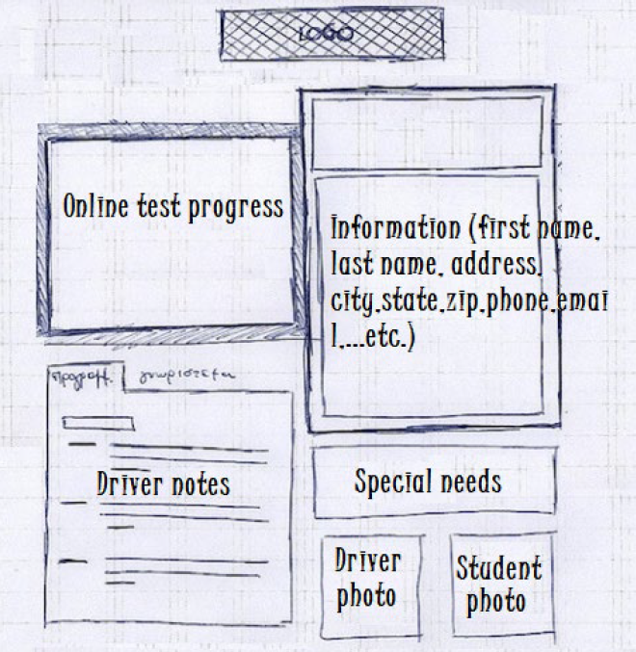

* + - The Online Test Progress module will display the lessons and tests the student has taken so far, with information such as test name, time taken, score, and status (statuses could be not taken, in progress, failed, or passed).
    - The Driver Notes module will display any comments the driving instructor left for each lesson. This information will be provided in the format of Liam’s table shown below, per page 4 of the DriverPass Interview Transcript document.

|  |  |  |  |
| --- | --- | --- | --- |
| **Lesson Time** | **Start Hour** | **End Hour** | **Driver Comments** |
|  |  |  |  |
|  |  |  |  |

* + There should be a page allowing students and/or the DriverPass secretary to enter the following general student information and their driving lesson registration details:
    - First name.
    - Last name.
    - Address.
    - Phone Number.
    - State.
    - Credit card information (number, expiration date, and security code).
    - Pickup and drop off location.
      * System should verify that these locations are the same.
  + There should be a contact page allowing communication between the student and DriverPass staff.
* For students
  + For student accounts
    - Ability to schedule appointments over the internet.
    - Ability to reset their forgotten password.
  + For making reservations
    - Ability for students to choose from the following packages:
      * Package 1
        + Three two-hour lessons in a car with a driving instructor.
      * Package 2
        + Four two-hour lessons in a car with a driving instructor.
        + In-person lesson explaining DMV rules and policies.
      * Package 3
        + Four two-hour lessons in a car with a driving instructor.
        + In-person lesson explaining DMV rules and policies.
        + Full access to online class content.
      * Option to disable any packages in the future.
    - Ability to create, modify, or remove reservations through a student’s account or phone call with the DriverPass secretary.
    - System confirmation of driving instructor and vehicle availability for each driving lesson.
      * There are up to 10 cars to pick from, each with their own driving instructor.
* Jennifer, one of our consulting representatives, has produced a timeline with all lifecycle phases with corresponding start and end dates shown below, per page 6 of the DriverPass Interview Transcript document. Note: this is the latest version of the timeline.

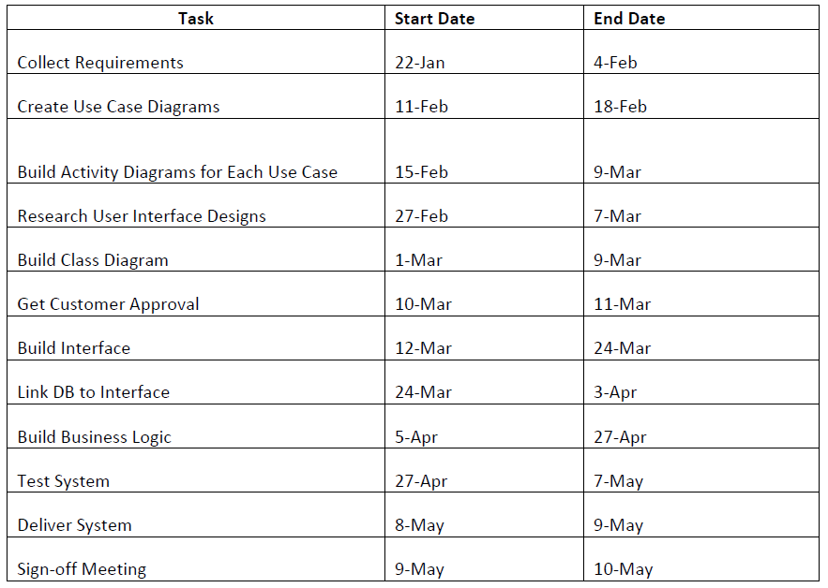

## Requirements

### Nonfunctional Requirements

#### Performance Requirements

* Environments
  + The system must be capable of running in common web-based environments like Mac OS and Windows.
  + The system must be capable of running in common mobile environments like iOS and Android.
* System Speed
  + The system must be responsive to users’ requests and/or input.
    - For example:
      * The user should be able to promptly input their profile/payment information.
      * The user should be able to take a practice exam or view lessons with little to no delay, barring any internet connection issues.
      * The system should be able to promptly serve clients (staff/students) and update the DriverPass system (i.e., grading exams, saving updated profile/payment information, notifying DriverPass staff of any changes in the system, etc.).
* System Updates
  + Currently, Liam is not considering further updates to the system’s features but will notify us if any new ideas arise.
  + The system should update staff/student information promptly after input by the user.
  + System diagnoses and checks/backups should occur per diem to ensure all information is up to date.

#### Platform Constraints

* Platforms
  + Desktop: Mac OS and Windows.
  + Mobile: iOS and Android.
* Tools
  + Cloud-based tools will allow DriverPass to focus on deploying and maintaining features of their application without requiring extra costs for dedicated server maintenance and real estate fees for storing their own servers. Such cloud-based tools can be:
    - Web hosting, for the DriverPass website.
    - App hosting, for the DriverPass application.
    - Storage, for storing DriverPass user data and course content.
    - Learning Management Systems (LMS), for remote DriverPass courses and exam practice.

#### Accuracy and Precision

* Users must register for an account using a unique email and password combination.
  + Email input will not be case sensitive.
  + Password input will be case sensitive.
  + If a user attempts to log in with an incorrect email and password combination, they will be prompted with a message saying, “Credentials are invalid”, and will not be allowed to access DriverPass content.
* User accounts will be distinguished by the email used at the point of registration.
  + If a user attempts to create another account with the same email, they will be prompted with a message saying, “Email already in use”, and will not be allowed to register another account with this credential.

#### Adaptability

* Users can be added, removed, or modified without changing code. There will be a function for each of these given operations (i.e., addUser, removeUser, modifyUser).
* The system will adapt to platform changes on cloud servers. This means that platform updates can happen instantaneously as soon as the development team uploads the updated code/changes to the cloud service.
* The IT administrator must be able to view audit logs and deploy all changes and modified code in the DriverPass system, both on the frontend and backend.

#### Security

* The user must log in with their valid email and password combination which was created at the point of registration.
* If the user forgets their password, they must be able to reset it. The user will type in their email, which will then receive a code, which the user types into the DriverPass password reset page to create and confirm a new password.
* If there is a “brute force” hacking attempt, or excessive incorrect login attempts for an account, the account should be temporarily locked and the email of the account should receive a message of this event. The message should also prompt the user to reset their password and report the incident to the DriverPass system administrator for further inquiry.
* To secure the connection or data exchange between the client and server, encryption keys or certificates must be used at the beginning and end of each connection/exchange. This ensures that data cannot be exposed during transit.

### Functional Requirements

* The system shall allow Liam (DriverPass Owner) to access data on any platform, online or offline.
* The system shall allow Ian (IT Officer) full access to all accounts to control rights, roles, and access for each user and their account.
* The system shall allow Ian (IT Officer) the ability to generate activity reports or audit logs to track who makes changes to records in the system (i.e., creating, modifying, or removing reservations).
* The system shall ensure that digital and in-person DriverPass content adheres to DMV’s requirements.
* The system shall maintain a connection to DMV for current rules, policies, and sample questions.
* The system shall have a notification system for DMV updates.
* The system shall run off the web, cloud computing preferred.
* The system shall have backup and security taken care of by the cloud or a third-party service.
* The system shall allow new users to register a DriverPass account.
* The system shall validate user credentials when logging in.
* The system shall allow users to reset their password when needed.
* The system shall lock a user account in the event of a brute force hacking attempt.
* The system shall allow users to modify and save their personal and payment information under their account.
* The system shall allow users to select a DriverPass education package.
* The system shall allow users to book, modify, and cancel driving lessons.
* The system shall allow users to access and interact with DriverPass content online if applicable.

### User Interface

* Per *Objectives and Goals* of *System Components and Design* on Page 1:
  + Interface design needs to adhere to Liam’s sketch shown below, per page 4 of the DriverPass Interview Transcript document.

* + - The Online Test Progress module will display the lessons and tests the student has taken so far, with information such as test name, time taken, score, and status (statuses could be not taken, in progress, failed, or passed).
    - The Driver Notes module will display any comments the driving instructor left for each lesson. This information will be provided in the format of Liam’s table shown below, per page 4 of the DriverPass Interview Transcript document.

|  |  |  |  |
| --- | --- | --- | --- |
| **Lesson Time** | **Start Hour** | **End Hour** | **Driver Comments** |
|  |  |  |  |

* Users of the Interface
  + Owner
    - Liam will possess this role.
    - Permissions:
      * Liam must see all data from all user roles on the platform, online or offline.
      * Liam must be able to generate and view reports.
    - Functions:
      * Liam will be able to view and interact with the data of the frontend and backend layers of the DriverPass application.
  + Admin
    - Ian will possess this role.
    - Permissions:
      * Ian must have full access to all accounts and the ability to control rights, roles, and access for each user and their account.
      * Ian must be able to generate and view audit logs.
    - Functions:
      * Ian will be able to view, interact with, and modify the data and software of the frontend and backend layers of the DriverPass application.
  + Staff
    - The DriverPass secretary and other company administrative staff will possess this role.
    - Permissions:
      * Staff must be able to access, edit, and confirm Student accounts’ data regarding personal information and appointment information.
    - Functions:
      * Staff will be able to view, interact with, and modify the data of the backend layers of the DriverPass application.
  + Student
    - DriverPass customers will possess this role.
    - Permissions:
      * Students must be able to access, edit, and confirm their personal, payment, and appointment information.
      * Students must be able to access DriverPass course content if applicable to their selected package.
    - Functions:
      * Students will be able to view and interact with the data of the frontend layers of the DriverPass application.

### Assumptions

* All DriverPass staff and customers are proficient in using technology and the internet.
* All DriverPass staff and customers have a compatible desktop and/or mobile device.
* All DriverPass staff and customers have a stable internet connection.
* All DriverPass customers are taking their driving exam in the United States.
* All DriverPass staff and customers can read and write in English.
* DMV has a system DriverPass can connect to for compliance.

### Limitations

* System Design
  + The interface needs to be accessible and interactive for all users.
  + The system needs to handle multiple client-server connections.
  + The system needs to be scalable if DriverPass expands.
* Resources
  + DMV provides compliance measures but may not provide all information needed for preparation (i.e., driving confidence, driving a specific vehicle, driving manual, etc.).
  + DriverPass must provide students with online lessons for all topics covered on the DMV exam, if applicable to the student’s package tier.
* Time
  + The application is expected to be delivered within 5 months.
  + DriverPass must offer courses that allow students to prepare in a timely manner, regardless of package tier.
* Budget
  + DriverPass may need to hire a customer service team to keep up with customer demand and inquiries.
  + DriverPass may need to contract development teams again in the future for any big updates to the application.
* Technology
  + DriverPass will need to keep the application updated for the latest operating system versions.
  + DriverPass will need to select a scalable and responsive cloud service to host their website and mobile application.
  + DriverPass must be reasonably prepared for data breaches or hacks.

### Gantt Chart

